2. Add three new models fitted to all 5 variables to the 10-fold CV comparison that has

been used for LASSO, Ridge, and other methods: Full tree (CP=0), min-cv-pruned tree,

and 1-se-pruned tree. Use the same folds as before.











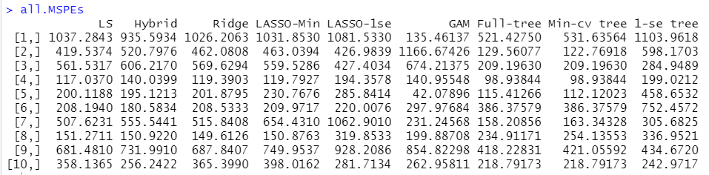

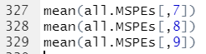

(a) **Compute the mean MSPE for each tree model and comment on the**

**comparison.**

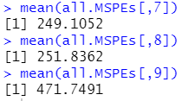

Full-tree and Min-cv tree has similar small MSPEs and 1-se tree has quite larger MSPE.

(b) **ADD the three trees to the relative MSPE boxplots made previously.**

**Comment on how well they perform compared to other methods.**

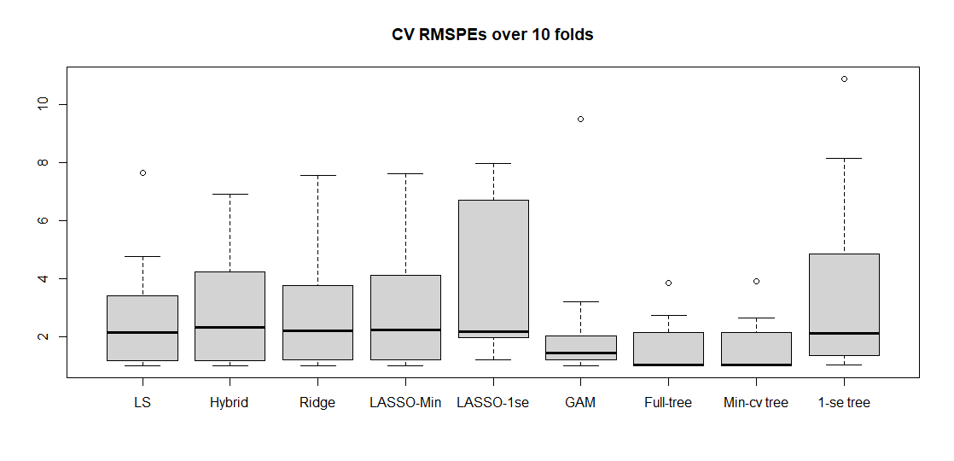

So far, it looks like Full-tree and Min-cv tree and GAM show the best result. However, 1-se tree doesn’t do well on it.